The Hague, 15 of May, 2023

Conference: **Bringing Justice for Ukraine. Crimes of aggression, Ware Crimes, Crimes against Humanity, Crimes of Genocide**

The Polish and Ukrainian national groups of the International Association of Penal Law (AIDP; <https://www.penal.org/> ), the EU Project Pravo-Justice (<https://www.pravojustice.eu/> ) and the Project Sunflowers (<https://projectsunflowers.org/> )sincerely invite you to participate in a conference to be held on **19 May 2023** on the **Zoom** platform. The event will **start at 9:00 a.m. CET and end at 3:00 p.m. CET.**

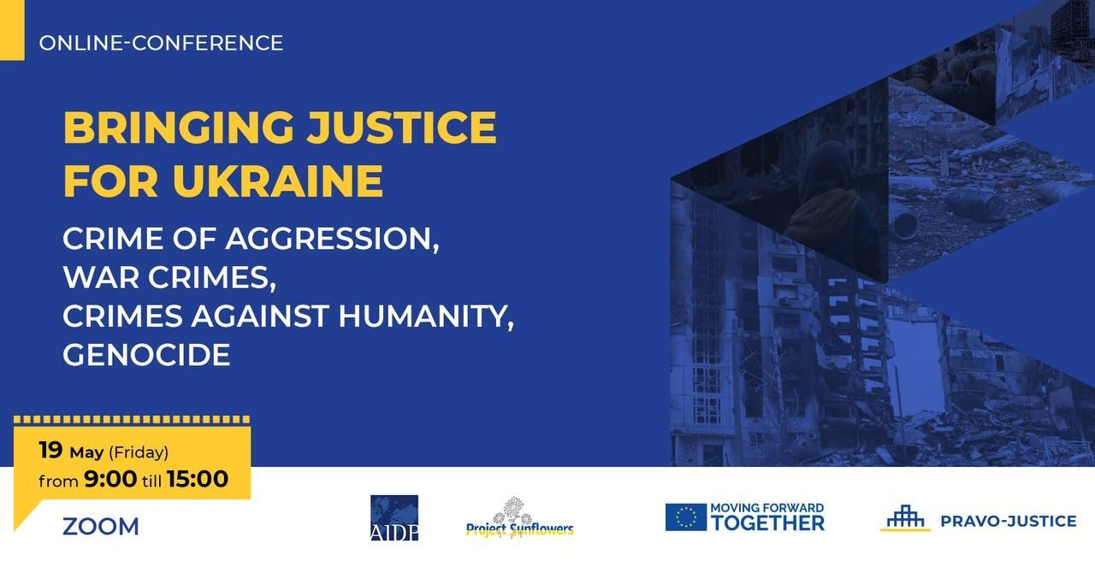

The aim of the conference is to discuss Ukrainian and Polish lawyers with the participation of prominent international experts in criminal law on the legal and practical aspects of bringing perpetrators of crimes committed in Ukraine to justice.

The conference will present papers prepared by distinguished Guests: practitioners, judges, prosecutors, professors of criminal law and international law. Representatives of Ukraine will provide an update on the status of ongoing criminal trials in Ukraine for war crimes and crimes against humanity (and some 70,000 cases have already been opened). In addition, the most hot topics related to criminal responsibility for crimes committed in Ukraine will be discussed. The organisers have also provided time and space for discussion. Participants of the conference will learn about the current state of work on the proposal to establish a Special Tribunal for Crimes of Aggression. Undoubtedly, participation in the conference is a great opportunity to exchange views and interact with lawyers from Ukraine, who have to solve on an ongoing basis a myriad of problems concerning the application of criminal law in the current situation.

**Link to registration:**

<https://us06web.zoom.us/webinar/register/WN__zypx9lETIeaKsINuqv50A#/registration>

**More information**: [contact@projectsunflowers.org](mailto:contact@projectsunflowers.org)